**Year 10 Physics Topic Test One**

**Name: \_\_\_\_\_\_\_\_\_\_\_\_\_\_\_\_\_\_\_\_\_\_\_\_\_\_\_ /40**

**Formula you may need**

[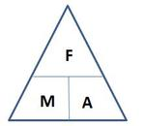](http://www.google.com.au/url?sa=i&rct=j&q=force+mass+acceleration+triangle&source=images&cd=&cad=rja&docid=O6V53PkQA165NM&tbnid=vhNrW-efYEJTlM:&ved=0CAUQjRw&url=http://jdevlin.pottsgrove.wikispaces.net/Physics+Tasks+2012&ei=z6IRUqS2NYyXkgXUoIDwCg&psig=AFQjCNGaoVG_TT9V-bDQMdMZk8qwyYJa6Q&ust=1376973888721903)[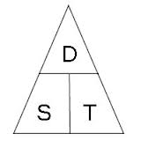](http://www.google.com.au/url?sa=i&rct=j&q=speed%20distance%20time%20triangle&source=images&cd=&cad=rja&docid=l-Td1q_Q0MI0IM&tbnid=cC1NHwB6_ZXB3M:&ved=0CAUQjRw&url=http://www.skoool.co.za/studynotes/maths/id270.htm&ei=haIRUr72K8GHkQX8qoHACw&psig=AFQjCNFf-ofXYSPuXljl_uBwHvbcdC6D5A&ust=1376973815450016)

[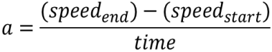](http://www.google.com.au/url?sa=i&rct=j&q=formula+acceleration&source=images&cd=&docid=n1BQvXMu3V1gnM&tbnid=tyy5e7co4fxZgM:&ved=0CAUQjRw&url=http://www.etorgerson.net/WebPages/ScienceUnits/A04_Acceleration.html&ei=ivH1UbrJMIiPkwW0pYD4Bg&psig=AFQjCNGKaO8mY3zS4cauOZdzzpsrQErjaw&ust=1375159034805046)

**Multiple Choice Answer Sheet – Select ONE answer for each**

1. A B C D

2. A B C D

3. A B C D

4. A B C D

5. A B C D

6. A B C D

7. A B C D

8. A B C D

9. A B C D

10. A B C D

11. A B C D

12. A B C D

13. A B C D

14. A B C D

15. A B C D

16. A B C D

17. A B C D

18. A B C D

19. A B C D

20. A B C D

[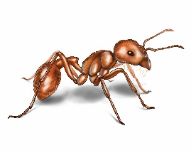](http://www.google.com.au/url?sa=i&rct=j&q=ant&source=images&cd=&cad=rja&docid=xnY1A86yla2paM&tbnid=RzulS6ugMKx4fM:&ved=0CAUQjRw&url=http://www.orkin.com/ants/harvester-ant/&ei=dZs7UrXWFNDDkAWDrIHoDA&psig=AFQjCNH_SG2m2KFbnhWkRaDTwREnye2S-g&ust=1379724529024052)**1** What distance would an ant, crawling at a speed of 2 centimetres per second, cover in an hour?

A 120 cm

B 7200cm

C 1200m

D 7200m

**2** Chris applies a 90 N to a 65 kg bin. The bin will accelerate at:

[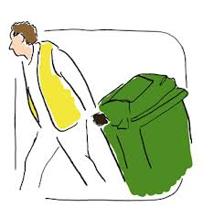](http://www.google.com.au/url?sa=i&rct=j&q=put+out+wheely+bin&source=images&cd=&cad=rja&docid=29pzR1WcQ3u_eM&tbnid=3Co3y0nBE_mw2M:&ved=0CAUQjRw&url=http://www.oxfordshire.gov.uk/cms/content/rubbish-and-recycling-oxfordshire&ei=g9A7UsKpCIKIkwWw6YH4Dg&psig=AFQjCNGHJ3ZxsU6cRHbs3zRqdJid1aroRw&ust=1379738041806358)A 0.138 m/s2

B 1.38 m/s2

C 5850 m/s2

D 58.5 m/s2

**3** Look at the three pieces of ticker tape below, labelled A, B and C.

Choose the answer that explains each piece correctly.

[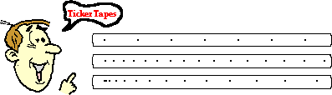](http://www.google.com.au/url?sa=i&rct=j&q=ticker+tape+speed&source=images&cd=&cad=rja&docid=wMhrNsjROP9a0M&tbnid=vzACHjSPZdrteM:&ved=0CAUQjRw&url=http://www.nileswestils.com/ILS/Acceleration.html&ei=-tA7UrGqKIfdkgXOt4HIBA&psig=AFQjCNH19iGDLCD5X9W_FaHQYkKvniD58g&ust=1379738197384806)

**A**

**B**

**C**

|  |  |  |  |
| --- | --- | --- | --- |
|  | Piece A | Piece B | Piece C |
| A | Decelerating | Maintaining a constant speed | Accelerating |
| B | Maintaining a constant speed | Accelerating | Decelerating |
| C | Accelerating slowly | Maintaining a constant speed | Decelerating |
| D | Maintaining a constant Speed | Accelerating Slowly | Accelerating faster |

**4** To convert joules to kilojoules you:

A multiply the joules by 1000.

B divide the joules by 1000.

C multiply the kilojoules by 1000.

D divide the kilojoules by 1000.

**5** An aircraft is flying in a straight line at constant altitude and at a constant speed. What can be said about the forces on the aircraft?

A The forces are unbalanced.

B The forces are balanced.

C The forces are compression forces.

D The aircraft is accelerating.

**6** Which of Newton’s Laws of Motion involve inertia:

A Newton’s First Law of Motion

B Newton’s Second Law of Motion

C Newton’s Third Law of Motion

D All of the above

**7** Which of the following statements best describes the “net Force” on an object?

A The sum of all the forces

B The difference between the biggest and smallest forces

C Multiplying all forces together

D None of the above

**8** Newton realised that forces always occur in:

A balanced parts

B unbalanced parts

C sequences

D pairs

**[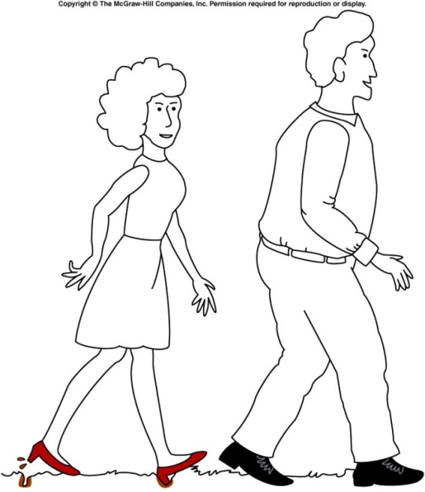](http://www.google.com.au/url?sa=i&rct=j&q=pressure+high+heel&source=images&cd=&cad=rja&docid=nxP8BgFtQrkhwM&tbnid=dVIUZoWEAPzlTM:&ved=0CAUQjRw&url=http://onlinephys.com/pressure.html&ei=hfU3Uoq9C8WfkwW2toHQAg&psig=AFQjCNGIEB4RESz64D3f84yVrSv_95GNLw&ust=1379485420790197)9** Which of the following is **true** about the diagram of the man and woman walking?

A The woman is making marks in the ground because she is placing more force on the grass

B The man is not making any marks on the ground because he is placing less force on the grass

C The woman is making marks on the ground because her shoes have less area touching the ground

D The man’s shoes are not making any marks on the ground because his have less area touching the ground

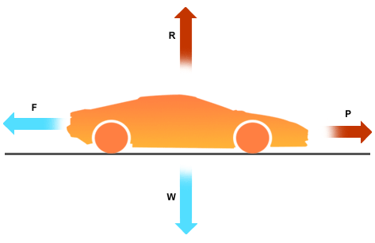**10** Which of the following is **correct** about the movement of the car?

A The car is still

B The car is at a constant speed

C The car is accelerating

D The car is decelerating

**11** Leslie runs a race that starts and finishes at the same point. If the race was 1000 metres, what was Leslie’s displacement at the end of the race?

A 1000 metres

B 500 metres

C 10 metres

D 0 metres

[](http://www.google.com.au/url?sa=i&rct=j&q=force+mass+acceleration+triangle&source=images&cd=&cad=rja&docid=O6V53PkQA165NM&tbnid=vhNrW-efYEJTlM:&ved=0CAUQjRw&url=http://jdevlin.pottsgrove.wikispaces.net/Physics+Tasks+2012&ei=z6IRUqS2NYyXkgXUoIDwCg&psig=AFQjCNGaoVG_TT9V-bDQMdMZk8qwyYJa6Q&ust=1376973888721903)**12** These variables relate to which of Newton’s Laws of Motion?

A Newton’s First Law

B Newton’s Second Law

C Newton’s Third Law

D All three of the Laws of Motion

1. **13**  Which of the following stick people would be unstable and most likely to topple over?

|  |  |  |  |
| --- | --- | --- | --- |
| A | PSCI_10PR_9_12Ta | B | PSCI_10PR_9_12Tb |
| C | PSCI_10PR_9_12Tc | D | PSCI_10PR_9_12Td |

**14.** Look at the data in this table.

|  |  |
| --- | --- |
| Type of car | Time taken to reach 100km/h from rest (minutes) |
| Ariel Atom V8 | 2.5 |
| Nissan GTR | 3 |
| [Lamborghini Aventador](http://news.drive.com.au/drive/motor-news/first-drive-lamborghini-aventador-20110602-1fhci.html) | 2.9 |

Of the cars in the table above which has the fastest acceleration?

(a) Ariel Atom V8.

(b) Nissan GTR.

(c) Lamborghini Aventador.

(d) This question cannot be answered with the information in the table.

*Questions 15 and 16 refer to the diagram on the right:*

*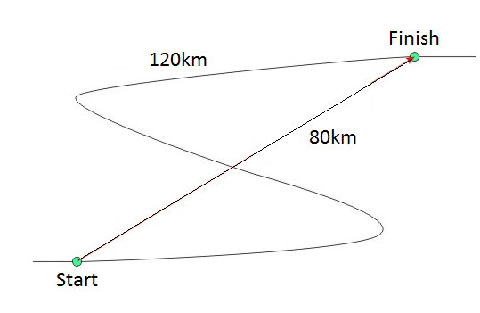***15.** The distance travelled is:

(a) 120km.

(b) 40km.

(c) 80km.

(d) 200km.

**16.** Choose the correct statement below.

(a) The distance is greater than the displacement.

(b) The displacement is greater than the distance.

(c) The distance and displacement are the same.

(d) The displacement is sometimes a straight line distance and direction.

**17.** Which of the following is NOT an SI unit?

(a) m/s²

(b) s

(c) km/s

(d) kg/m

**18.** A train travels at a speed of 18 m/s. This is equivalent to:

(a) 5 km/h

(b) 64.8 km/h

(c) 64 800 km/h

(d) 0.005 km/h

**19.** Inertia can be defined as:

(a) The amount of matter in an object

(b) The tendency of an object to resist a change in motion

(c) The force of gravity on an object

(d) When a force makes something move

**20.** A 90N force is applied to a mass of 65kg. The mass will accelerate at:

(a) 0.72 m/s²

(b) 1.2 m/s²

(c) 1.4 m/s²

(d) 5.9 m/s²

**Short Answer**

**1** Classify the following as situations in which forces are balanced or unbalanced: (4 Marks)

a) A motorbike is accelerating away from traffic lights. \_\_\_\_\_\_\_\_\_\_\_\_\_\_\_\_\_\_\_\_

b) A car is travelling at 100 km/h straight down a freeway. \_\_\_\_\_\_\_\_\_\_\_\_\_\_\_\_\_\_\_\_\_

c) A surfer falls off their surfboard. \_\_\_\_\_\_\_\_\_\_\_\_\_\_\_\_\_\_\_\_\_

d) A bird flies into a window and bounces off. \_\_\_\_\_\_\_\_\_\_\_\_\_\_\_\_\_\_\_\_\_

**2** Calculate the average acceleration of a car (km/h/s) that began traveling at 30 km/h at 1.00 pm. The car’s speed reached 110km/h at 1.15pm. Show your working. (2 marks)

**3.** Contrast distance and displacement.

(2 marks)

\_\_\_\_\_\_\_\_\_\_\_\_\_\_\_\_\_\_\_\_\_\_\_\_\_\_\_\_\_\_\_\_\_\_\_\_\_\_\_\_\_\_\_\_\_\_\_\_\_\_\_\_\_\_\_\_\_\_\_\_\_\_\_\_\_\_\_\_\_\_\_\_\_\_\_\_\_\_\_\_\_\_\_\_\_\_\_\_\_\_\_\_\_\_\_\_\_\_\_\_\_\_\_\_\_\_\_\_\_\_\_\_\_\_\_\_\_\_\_\_\_\_\_\_\_\_\_\_\_\_\_\_\_\_\_\_\_\_\_\_\_\_\_\_\_\_\_\_\_\_\_\_\_\_\_\_\_\_\_\_\_\_\_\_\_\_\_\_\_\_\_\_\_\_\_\_\_\_\_\_\_\_\_\_\_\_\_\_\_\_\_\_\_\_\_\_\_\_\_\_\_\_\_\_\_\_\_\_\_\_\_\_\_\_\_\_\_\_\_\_\_\_\_\_\_\_\_\_\_\_\_\_\_\_\_\_\_\_\_\_\_\_\_\_\_\_\_\_\_\_\_\_\_\_\_\_\_\_\_\_\_\_\_\_\_\_\_\_\_\_\_\_\_\_\_\_\_\_\_\_\_\_\_\_\_\_\_\_\_\_\_\_\_\_\_\_\_\_\_\_\_\_\_\_\_\_\_\_\_\_\_\_\_\_\_\_\_\_\_\_\_\_\_\_\_\_\_\_\_\_\_\_\_\_\_\_\_\_\_\_\_\_\_\_\_\_\_\_\_\_\_\_\_\_\_\_\_\_\_\_\_\_\_\_\_\_\_\_\_\_\_\_\_\_\_

**4.** Calculate the average speed (in m/s) of (4 marks)

**(a)** Brendan, who runs 882 metres in 4.2 minutes

**(b)** A gazelle that runs 10 kilometres in 7.5 minutes.

1. **5.** Tina exerts a force of 700 N on a 50 kg crate as shown below. (3 marks)
2. 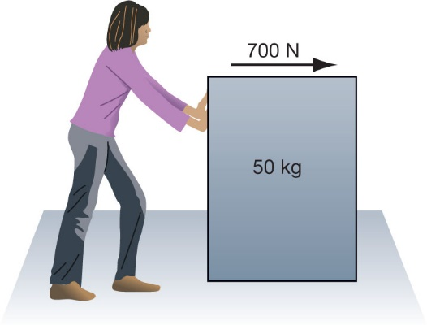
3. The crate accelerates at 9 m/s2.

(a) **Calculate** the size of the friction force acting on the crate.

(b) **Demonstrate** where this force acts by marking the force using an arrow on the diagram.

1. **6.** Using the speed–time graph shown below, calculate the:

(5 marks)

* 1. Distance travelled in the first 3 seconds.
  2. Total distance travelled
  3. Acceleration in the time interval from 4 seconds to 7 seconds.

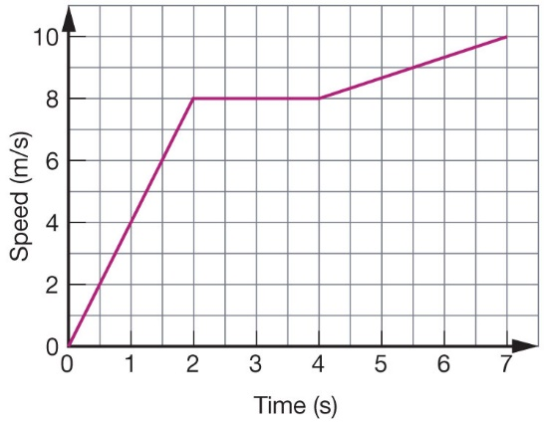

END OF TEST

**SOLUTIONS**

**Multiple Choice Answer Sheet**

1. A B C D

2. A B C D

3. A B C D

4. A B C D

5. A B C D

6. A B C D

7. A B C D

8. A B C D

9. A B C D

10. A B C D

11. A B C D

12. A B C D

13. A B C D

14. A B C D

15. A B C D

16. A B C D

17. A B C D

18. A B C D

19. A B C D

20. A B C D

**Short Answer**

**1.** Classify the following as situations in which forces are balanced or unbalanced: (4 Marks)

a A motorbike is accelerating away from traffic lights. Unbalanced

b A car is travelling at 100 km/h straight down a freeway. Balanced

c A surfer falls off their surfboard. Unbalanced

d A bird flies into a window and bounces off. Unbalanced

**2. 5.33 km/h/s** (2 Marks)

**3.** Distance refers to the total amount of distance travelled by an object from start to finish. Displacement is the distance of a straight line from the starting point to the end point.

4.

* 1. **4.** v = s/t  
     v = 882/ 4.2 × 60  
      = 3.5 m/s
  2. v = s/t  
      = 10 × 1000/ 7.5 × 60  
      = 22.2 m/s

5. **a** *F*net = *ma* = 50 × 9

1. *F*net = 450 N
2. *F*net = 700 – friction force
3. = 450 N
4. So friction force = 100 – 450
5. = 250 N

**b**

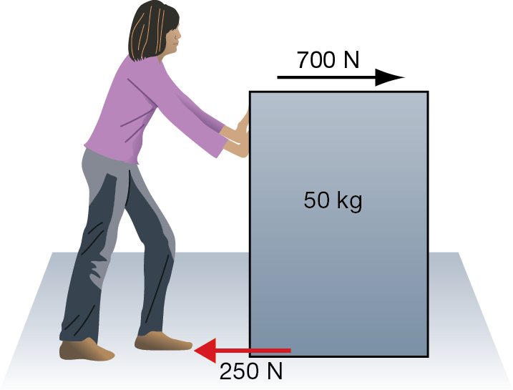

* 1. **6.** The area under the graph is equal to the distance travelled.  
     Area = area of triangle 0 to 2 seconds + area of rectangle  
     2 seconds to 3 seconds  
     Area = 8 + 8  
     Distance travelled in first 3 seconds is 16 m.
  2. Area = area of triangle 0 to 2 seconds + area of rectangle  
     2 seconds to 4 seconds + area of trapezium 4 to 7 seconds  
     Area = 8 + 16 + 27  
      = 51  
     Total distance travelled is 51 metres.
  3. Acceleration is the slope or gradient of a *v*–*t* graph  
     Slope = vertical rise/horizontal run  
      = 2/3 = 0.67  
     The acceleration in the time interval from 4 seconds to   
     7 seconds is 0.67 m/s2.

Speed of Car (m/s)

Time (Seconds)

The car speeds up quickly at 4 seconds and then slows down again at 8 seconds (2 marks)